Preliminary Literature Review

# Effects of different coolants and cooling strategies on the cooling performance of the power lithium ion battery system: A review

**Aim of Journal:** *The main aim of this work is to provide information to the engineers and researchers who are interested in lithium-ion battery liquid cooling system.*

*Li-Ion battery features:*

* High voltage platform, high energy density, low self-discharge and long cycle life
* Ideal operating temperatures are in the range of 20-40 C
* Specific power: 300 kW/kg
* Life cycles: >1000
* Self-discharge: 10%

*Safety Concerns:*

* At high operating temperatures, exceeding 80 C, thermal runway becomes a concern
* Thermal runway leads to harmful gas emissions, smoke, fires and possible explosions
* On the other hand, when charging at low temperatures lithium plating can occur, reducing battery life and threatening safety

*Air Cooling:*

* + Simple structure, lightweight, low cost.

Low thermal conductivity and low specific heat capacity leading to limited cooling performance.

*Phase Change Material:*

* Latent heat produced by the battery is absorbed by the PCM
* + Simple structure, lightweight, temperature difference between battery cells can be guaranteed
* - Low thermal conductivity so poor heat conduction

*Heat Pipes:*

* + Lightweight, compact and flexible geometry. Also, no external power supply is needed.
* It is recommended that heat pipes are combined with other cooling systems to improve overall heat transfer.

*Liquid Cooling:*

* + High thermal conductivity, high specific heat capacity. Also, low volume structure.

*Thermal models and heat generation:*

* Electro-thermal model: Capture heat generation, voltage and current variation of batteries. Accurate and improve computational efficiency.
* Electro-chemical model: Consider heat generation sources as electrochemical reactions active polarization and ohmic losses
* Thermal runaway model: Based on Energy Balance Equation, coupled with other models.
* Reversible heat is caused by entropy change and irreversible heat is caused by overpotential resistance and electrical resistance.

# A theoretical and computational study of lithium-ion battery thermal management for electric vehicles using heat pipes

**Aim of Journal:** *The article describes three different heat pipe designs and configurations then runs CFD simulations and* *transient computational model simulations in 1D. The article compares the heat pipe effectiveness with forced convection.*

*Heat Pipe Configuration:*

* When using a heat exchanger, it is generally best to use parallel cooling flow to minimize the heat variation
* 
* **Series Parallel**
* In a series configuration the flow rate is the same in all sections allowing the operator to easily control the flow velocity
* In a parallel configuration some sections house different flow rates than others, depending on flow resistance of each channel.
* ONLY use parallel IF pressure drop is unrealistic
* **The heat pipe used for the simulations was designed according to the maximum heat generated by the battery cell.
* For conservatism in the design, the simulation was performed with the maximum discharge rate of 5 C, corresponding to a discharge current of 100 A.
* Working fluid with a high wettability and chemical stability for the pipe material is desirable and operating temperature of the battery cell needs to be within the saturated state temperature interval of the working fluid.

***Thermal Network of a Heat Pipe***

* 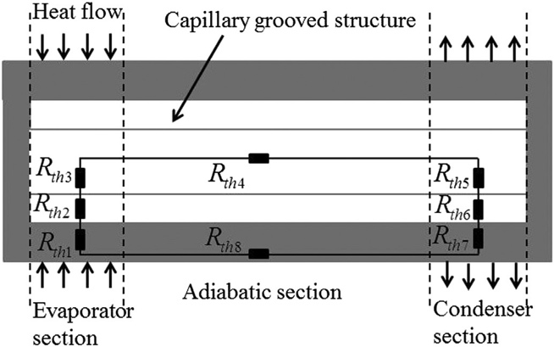
* Rth3 and Rth5 are due to the phase change, Rth4 is due to the flow of vapor, because of high thermal conductance (G) these can be neglected

$$G=\frac{1}{R_{th}}$$

# Investigation on the thermal performance of a battery thermal management system using heat pipe under different ambient temperatures

**Aim of Journal:** *The main aim of this work is to provide information on how the performance of the Li-Ion battery changes under varying ambient temperatures and how this then affects the heat generation and temperature uniformity of the battery.*

*Heat Pipe BTMS:*

* The battery temperature can be maintained in the required range when less than 30 W/cell is generated (coolant temp 25C)
* Temperature can be maintained under 40C if less than 10W/cell is generated
* Core cooling is where a heat pipe is placed through the center of a cylindrical battery cell.
* Thermal performance of a HP-BTMS under high ambient temperature should be enhanced by reducing coolant temperature.
* Low coolant temperatures adversely affect the uniformity of the temperature.
* By reducing cooling temperatures, the heat generation can be increased to 36W/cell from 20W/cell.
* Under 25C the heat generation increase is insignificant.
* The temperature variation is below 5C under ambient temperatures of 25C, 40W/cell, in this case the maximum battery temperature is 40+C
* On the other hand, the temperature variation is above 5C when ambient temp is less than 15C, 40 W/cell, Tmax is still within the range